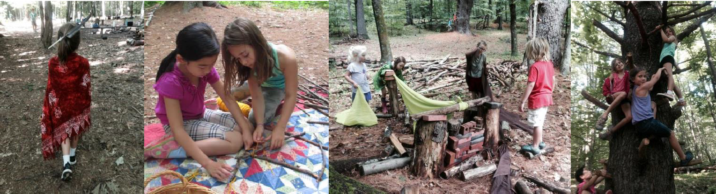

Our Observations and Experiences as a New TimberNook Provider!

Becoming a TimberNook provider was such a natural and obvious choice for us at Growing Places because we have so many of the same core values. We know children learn best through play and experiences that are open ended and process oriented. We know children need extended periods of time outside every single day, rain or shine.
TimberNook reminded us that we can do more to ensure that children have opportunities to play more deeply which helps them build essential life skills.

Children today spend so much time in adult led activities and research has shown us that what they need most is child- centered, freely-chosen, open-ended play. Providing children with longer play periods results in more sophisticated creativity, problem solving, planning and cooperation.

We got overwhelming positive feedback from Growing Places staff and parents who shared their observations and experiences from our TimberNook camps from the last few months and I want to share a few that stood out:
- “Something happens outside without walls and with more space that leads to many wonderful things. Adults are able to step back more which empowers children to problem solve on their own and with peers rather than turning to an adult for every answer. Children played and interacted more peacefully, they felt a sense of trust from the adults as they were able to spread out and choose where they wanted to be in the woods without being ‘fenced in’. Children took risks, made decisions and problem solved without the constant assistance of adults which helps them gain confidence.”
- “My child was very calm, relaxed and balanced after spending a day in the woods at TimberNook”.
- “The amount of creativity, problem solving, peer conflict resolution, communication, movement, risk taking, fun, peace and wonder that we observed in the woods is hard to share with words. I saw children grow more in one week than we often see over the course of months.”

- “Children became agitated/impatient much less…..when they did or if there was a conflict it did not get as much attention as it does in a classroom, it seemed to dissipate into the woods.”
- “Children with challenging behaviors and special needs (such as speech, language, sensory, emotional) were able to be included into the team work, play, learning and fun at camp. Successful inclusion of these children was almost ‘easy’ in the woods. A few children who typically have challenging needs had an extremely successful, productive and positive week at camp.”

Many of us have worked at Growing Places for years, decades even. Even with our vast experience, TimberNook has impacted us deeply. Our organization is committed to ongoing quality improvement and to incorporating deeper and more enriching play and environments for the children in our programs. Several classrooms have modified their daily routine to offer longer periods of time for children to immerse more fully in their play. Some classrooms have reduced or removed all the plastic toys and materials and replaced them with ‘real” dishes and items for children’s creative play. And teachers are incorporating even more risk taking than they were before, one long term teacher shares this “I want to encourage even more appropriate risks so children grow physically, socially and independently. There are so many opportunities for learning and in my role as teacher, I need to remember to step back and allow children the time to figure out life’s challenges such as how to communicate with peers or how to climb a tree”.

Children are growing, developing and learning essential life skills critical to their future success. Children practice critical thinking, problem solving, negotiating with peers, effective communication, and considering the thoughts and feelings of others. They begin learning to have focus and self-control and to be self-directed. We rely on these skills every day as adults and children begin developing these skills in their early years.

Our mission at Growing Places is to foster the development of the whole child. We recognize the responsibility and the opportunity we have to help lay a strong foundation for each child’s future success. As a TimberNook provider we have found one more way to help children thrive, develop a love of learning and to help them see that they can accomplish anything they set their mind to!

Cellissa Hoyt Executive Director

